MLOps Assignment 1 - Heart Disease Prediction
Machine Learning Operations (AIMLCZG523) - BITS Pilani
Name: Gadde Jaya Krishna Swamy
BITS ID: 2025ae05649
GitHub repository: https://github.com/2025ae05649-source/MLOps-cycle-assignment
Demo link : mlOps-assignment recording
Table of Contents
1. Introduction 1
2. Setup / Installation 2
3. Data Acquisition and Cleaning 2
4. Exploratory Data Analysis 3
5. Feature Engineering and Model Development 7
5.1 Features 7
5.2 Models and tuning 7
5.3 Results 7
6. Experiment Tracking (MLflow) 10
7. Model Packaging and Reproducibility 10
8. CI/CD Pipeline and Testing 10
8.1 Unit tests 10
8.2 GitHub Actions 11
9. Model Containerization (Docker) 11
10. Production Deployment (Kubernetes - Minikube) 12
11. Monitoring and Logging 13
12. Architecture 13
13. Challenges and Learnings 14
14. Links 14

1. Introduction
The goal of this assignment is to build a machine learning classifier that predicts the risk of heart disease from patient health data, and then take it through the full MLOps cycle: data download, EDA, model training, experiment tracking, testing, CI/CD, Docker, Kubernetes deployment and monitoring.
Tools used:
Area | Tool
Language | Python 3.12
Data / ML | pandas, scikit-learn
Plots | matplotlib, seaborn
Experiment tracking | MLflow
API | FastAPI + Uvicorn
Testing / lint | pytest, flake8
CI/CD | GitHub Actions
Container | Docker
Deployment | Kubernetes (Minikube)
Monitoring | Prometheus + Grafana

2. Setup / Installation
git clone https://github.com/2025ae05649-source/MLOps-cycle-assignment
cd heart-disease-mlops
python3 -m venv .venv
source .venv/bin/activate
pip install -r requirements.txt
python data/download_data.py # get + clean data
python src/eda.py # EDA plots
python src/train.py # train + log to MLflow
pytest -v # tests
mlflow ui --port 5001 # view experiments
Docker, Minikube and docker compose commands are given in the sections below and in README.md.

3. Data Acquisition and Cleaning
Dataset: Heart Disease UCI (Cleveland), 303 patients, 13 features + target.
The data is downloaded with the official UCI python package ucimlrepo (fetch_ucirepo(id=45)) in data/download_data.py. On macOS the python.org Python does not have SSL certificates set up, so the script points SSL_CERT_FILE to the certifi bundle before downloading.
Features: age, sex, cp (chest pain type), trestbps (resting blood pressure), chol (cholesterol), fbs (fasting blood sugar > 120), restecg, thalach (max heart rate), exang (exercise induced angina), oldpeak (ST depression), slope, ca (number of major vessels), thal.
Cleaning steps:
- Missing values: only ca (4 rows) and thal (2 rows) had missing values. Both are categorical, so I filled them with the mode instead of dropping rows (dataset is small).
- Target: the original num column has values 0-4. I converted it to binary: target = 1 if num > 0 else 0 (presence / absence of disease).
- Duplicates dropped (there were none).
- Categorical columns stored as floats were converted to int.
The cleaned data is saved as data/heart_clean.csv and committed to the repo.

4. Exploratory Data Analysis
EDA is in notebooks/eda.ipynb (with comments) and src/eda.py (saves the same plots to reports/figures/).
Class balance: 164 patients without disease and 139 with disease (54% / 46%). The classes are fairly balanced, so no resampling was needed, but I still look at precision, recall and ROC-AUC and not only accuracy.
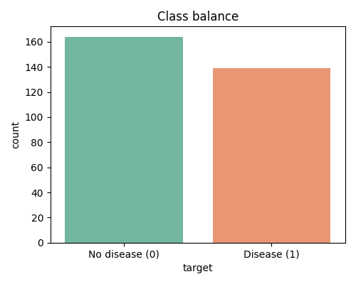
Class balance
Histograms: age is roughly normal (mostly 40-65). oldpeak is right skewed (about one third are 0). chol has 4 values above 400 which I kept as they can be real values.
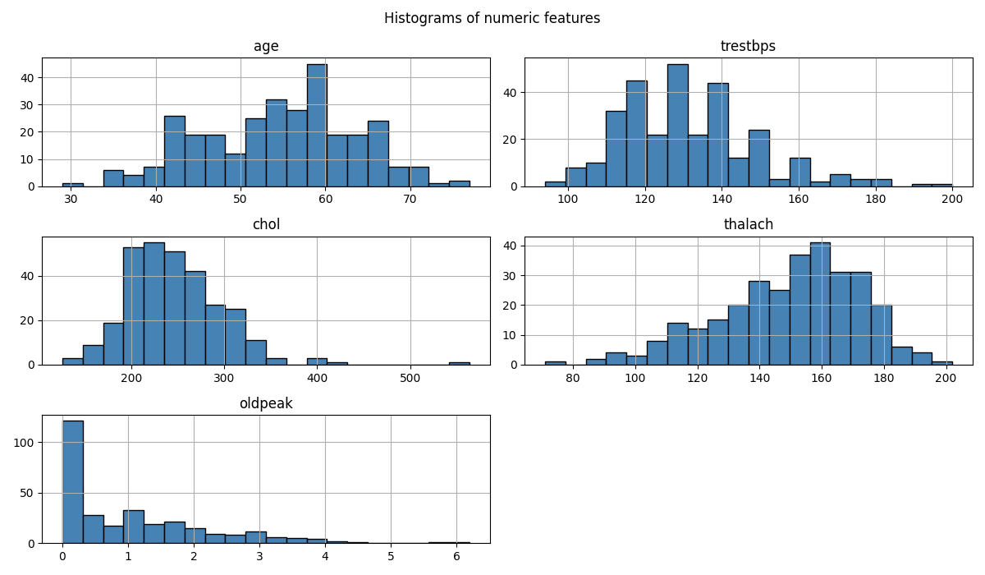
Histograms of numeric features
Correlation: the features most correlated with the target are thal (0.52), ca (0.46), exang (0.43), oldpeak (0.42), cp (0.41) and thalach (-0.42, higher max heart rate = lower risk). fbs and chol have almost no correlation with the target.
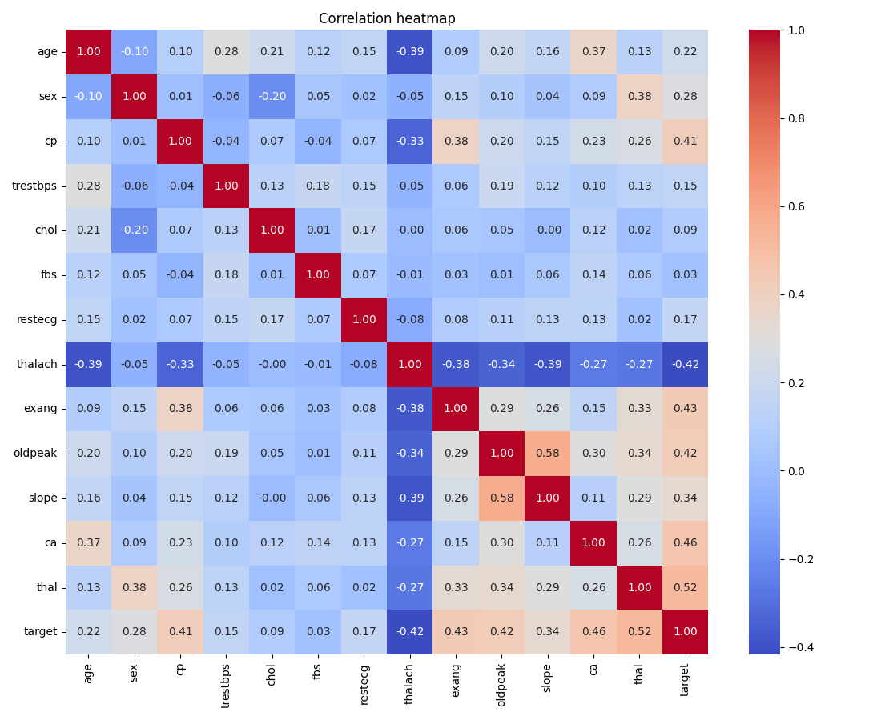
Correlation heatmap
Chest pain type: type 4 (asymptomatic) has 105 disease cases vs 39 no-disease, which is a strong signal.
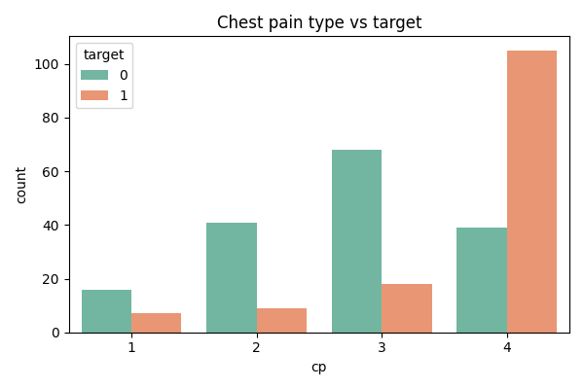
Chest pain type vs target
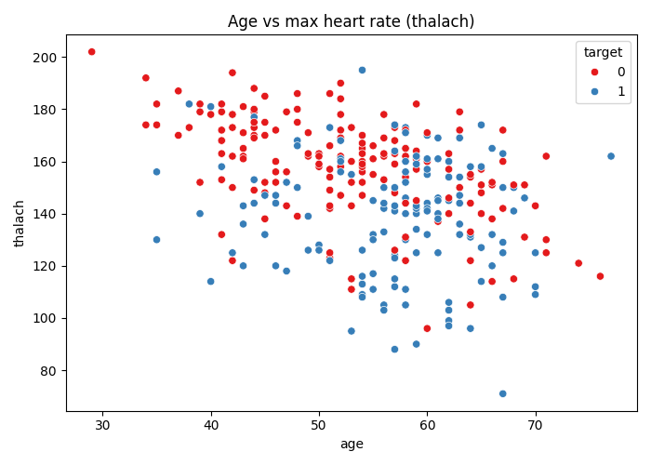
Age vs max heart rate

5. Feature Engineering and Model Development

5.1 Features
Based on the EDA I split the features into three groups (src/preprocess.py):
Group | Columns | Transformation
Numeric | age, trestbps, chol, thalach, oldpeak | StandardScaler
Categorical (>2 values) | cp, restecg, slope, ca, thal | OneHotEncoder (handle_unknown=“ignore”)
Binary | sex, fbs, exang | passthrough
These are combined in a scikit-learn ColumnTransformer, and the transformer + classifier are put into one Pipeline. This means the saved model file contains the preprocessing too, so the API only needs to send raw values and the same scaling/encoding is always applied (no training/serving mismatch).

5.2 Models and tuning
Data split: 80% train / 20% test, stratified, random_state=42.
Two models were trained (src/train.py):
- Logistic Regression - simple, fast, interpretable baseline. Grid: C in [0.01, 0.1, 1, 10].
- Random Forest - non-linear, handles interactions. Grid: n_estimators [100, 200], max_depth [4, 6, None], min_samples_split [2, 5].
Tuning: GridSearchCV with 5-fold StratifiedKFold, scoring = ROC-AUC. After finding the best parameters, I ran cross_validate again on the training data to get CV accuracy, precision, recall and ROC-AUC, and finally evaluated on the held-out test set.

5.3 Results
Model | Best params | CV acc | CV ROC-AUC | Test acc | Test precision | Test recall | Test F1 | Test ROC-AUC
Logistic Regression | C=1 | 0.847 | 0.904 | 0.885 | 0.839 | 0.929 | 0.881 | 0.968
Random Forest | 200 trees, max_depth=4, min_split=2 | 0.835 | 0.902 | 0.869 | 0.857 | 0.857 | 0.857 | 0.949
Model selection: both models are close in cross-validation. Logistic Regression has a higher test ROC-AUC and a much higher recall (0.93 vs 0.86). For a medical screening problem, missing a sick patient (false negative) is worse than a false alarm, so higher recall is preferred. It is also simpler and easier to explain. So Logistic Regression was selected as the final model and saved to models/model.pkl. Note the test set is small (61 rows) so the difference between the models is not very big.
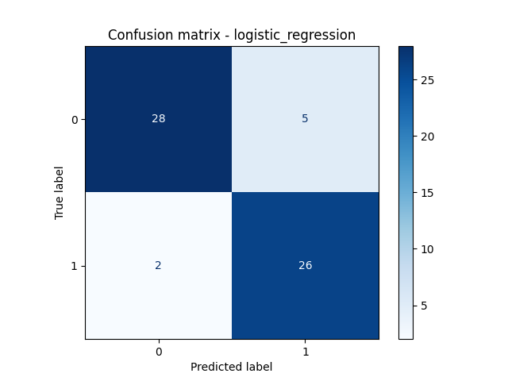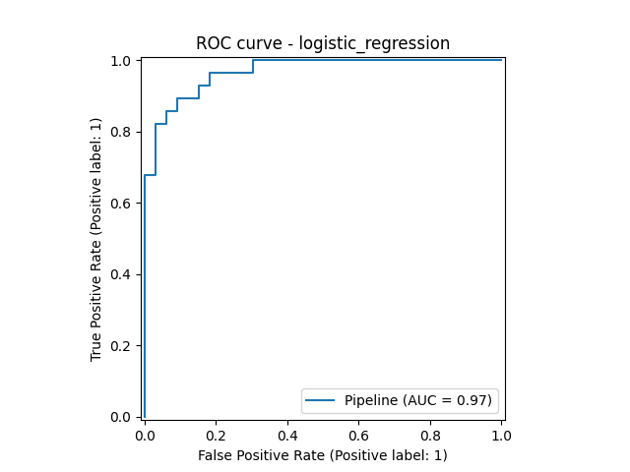

6. Experiment Tracking (MLflow)
MLflow is used in src/train.py. All runs go into the experiment heart-disease (stored locally in mlruns/). For every model run the following is logged:
- Parameters: model type and best hyperparameters from the grid search
- Metrics: cv_accuracy, cv_precision, cv_recall, cv_roc_auc, test_accuracy, test_precision, test_recall, test_f1, test_roc_auc
- Artifacts: confusion matrix and ROC curve plots (in plots/)
- Model: the full sklearn pipeline with mlflow.sklearn.log_model (with an input example and signature)
To view: mlflow ui --port 5001 and open http://localhost:5001. The runs can be compared side by side in the UI. In CI the mlruns/ folder is also uploaded as a workflow artifact.
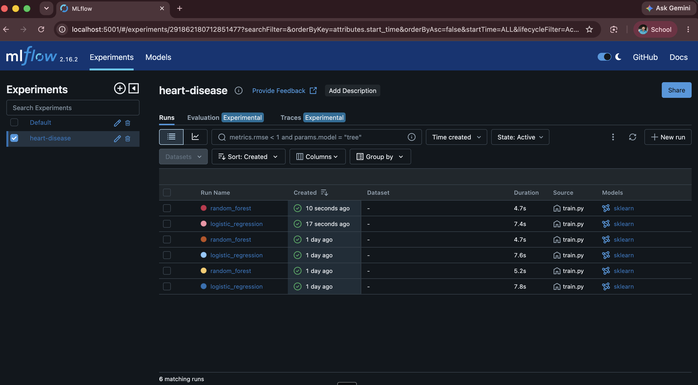

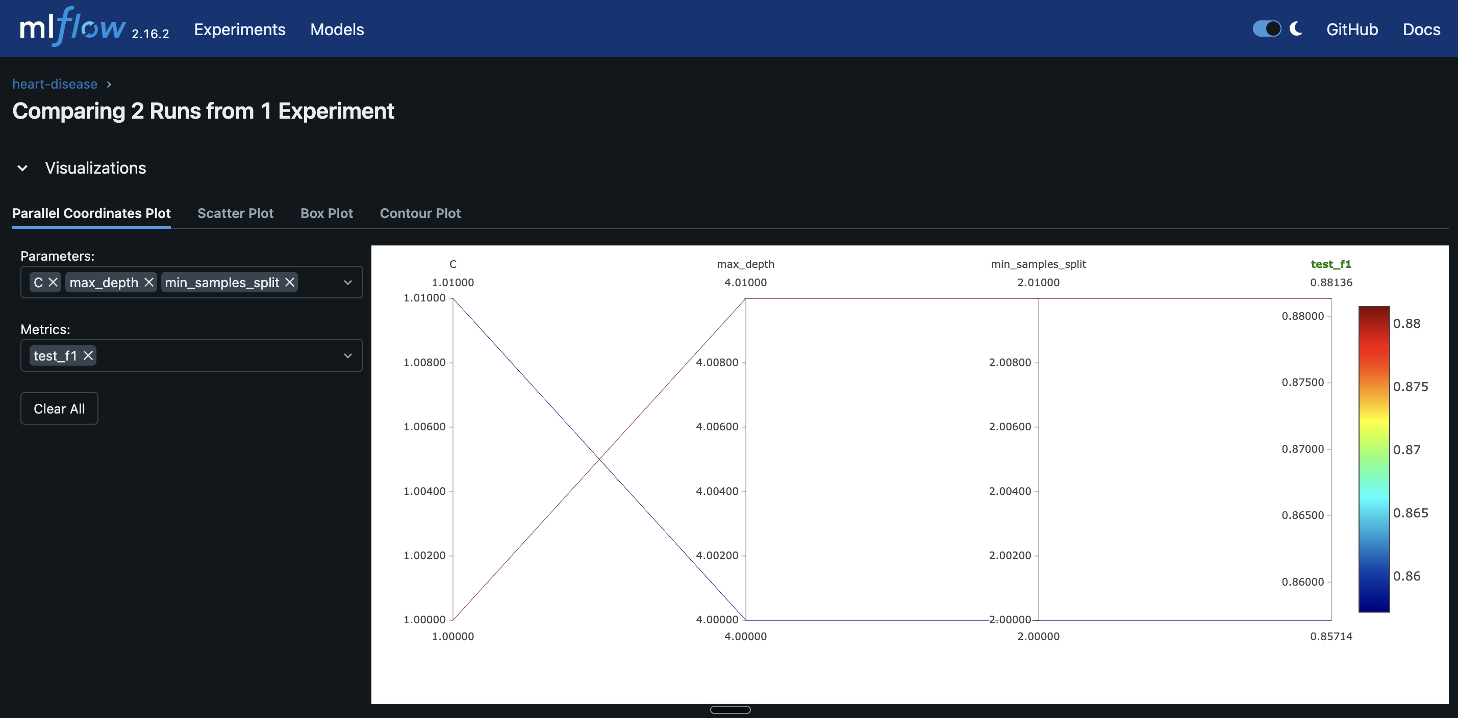
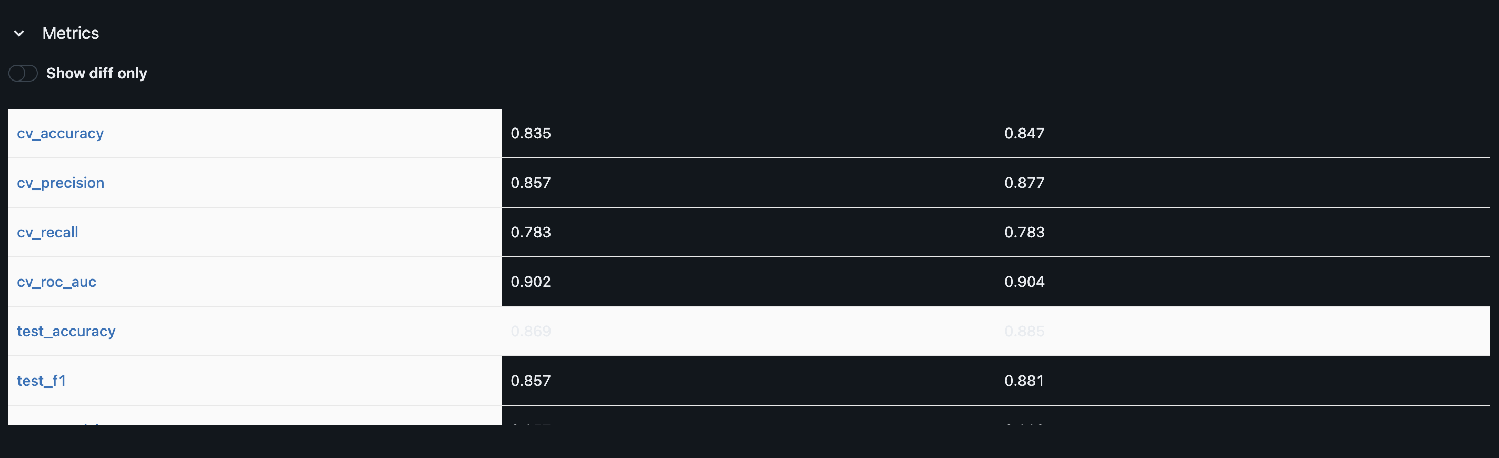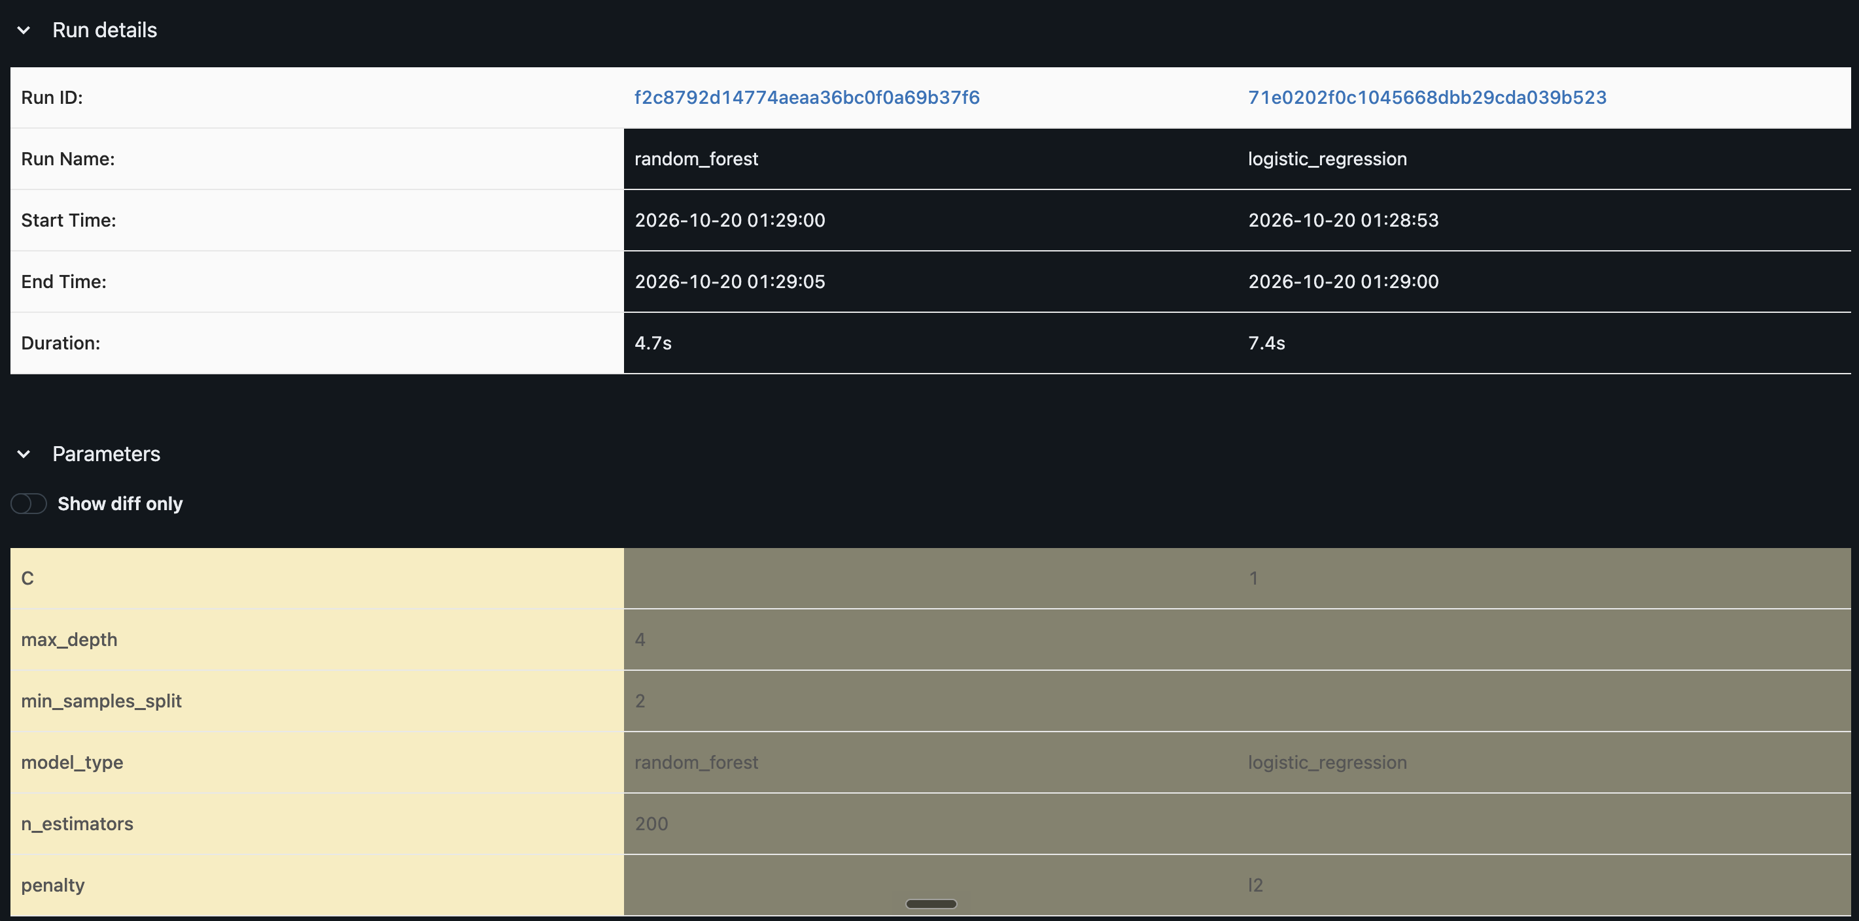

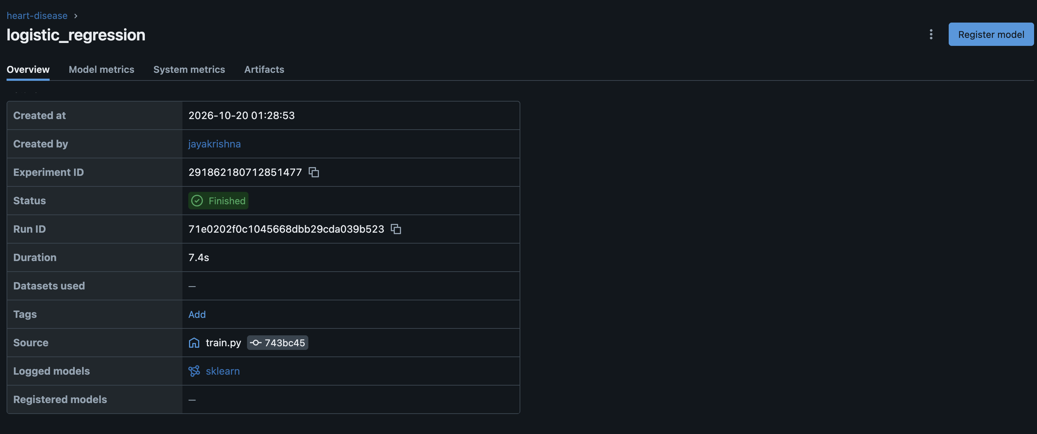
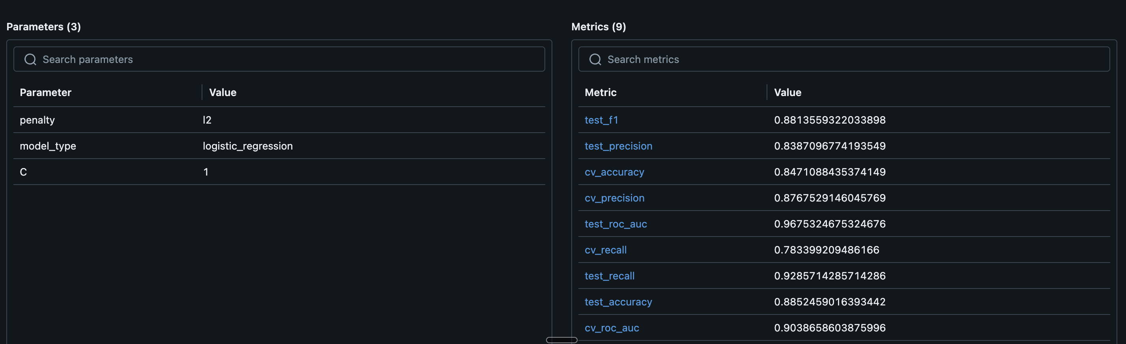

7. Model Packaging and Reproducibility
- The final model is saved as models/model.pkl with joblib. It is a full sklearn Pipeline (preprocessing + classifier), so loading this one file is enough to make predictions.
- The model is also saved in MLflow format inside each run.
- models/metrics.json stores the results and best params of both models.
- requirements.txt has pinned versions of all packages used for training and tests. requirements-api.txt is a smaller list just for the Docker image (no MLflow or plotting libraries), which keeps the image smaller.
- random_state=42 is used for the split, CV folds and Random Forest, so training gives the same results each time.
- I checked reproducibility by creating a fresh virtual environment, installing only requirements.txt on a clean copy of the repo, and running lint, training and tests - same results (test ROC-AUC 0.9675, 13 tests passed).

8. CI/CD Pipeline and Testing

8.1 Unit tests
Tests are in tests/ (13 tests, pytest):
File | What it tests
test_data.py | cleaning fills missing values, target becomes binary, cleaned file is valid, error on missing columns, preprocessor output shape
test_model.py | both models defined, model accuracy > 0.7, evaluate() returns all metrics in [0,1], predict() on a sample
test_api.py | /health returns ok, /predict returns prediction + confidence, missing field returns 422, /metrics works
[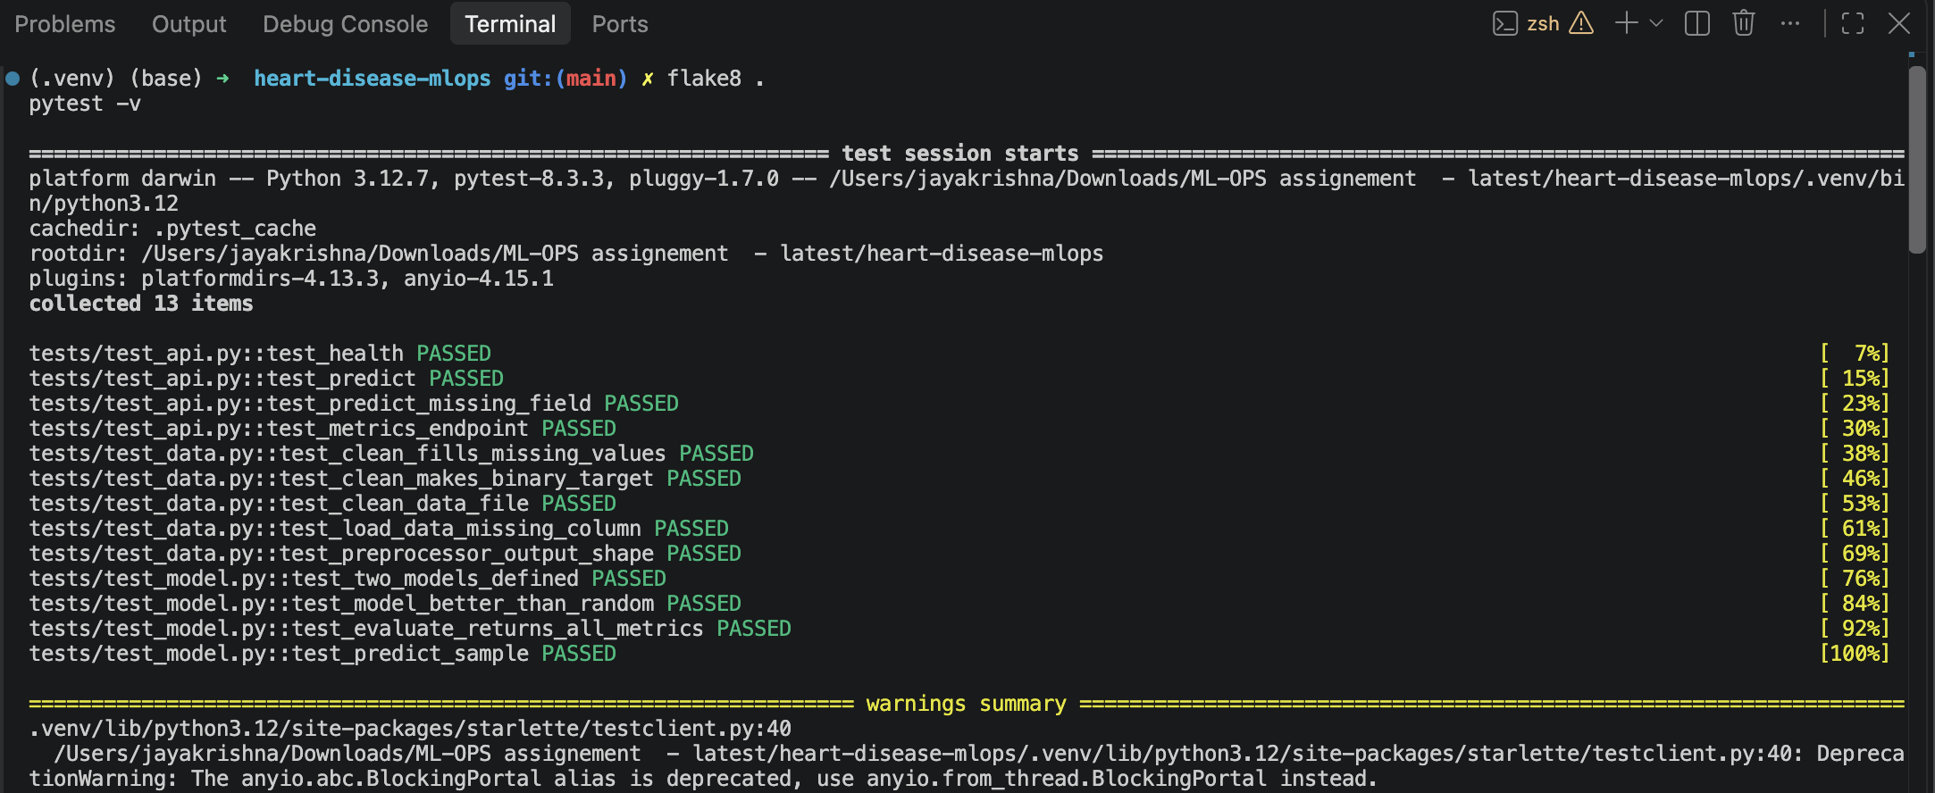

8.2 GitHub Actions
Workflow file: .github/workflows/ci.yml. It runs on push to main, on pull requests, and manually.
Job 1 - lint-test-train
- Checkout and set up Python 3.12 (with pip cache)
- Install requirements.txt
- Lint with flake8
- Train models (python src/train.py)
- Run pytest (writes test-results.xml)
- Upload artifacts: model-and-metrics (model, metrics.json, plots, test results) and mlruns
Job 2 - docker-build (runs only if job 1 passed)
- Download the trained model artifact
- Build the Docker image
- Start the container and call /health and /predict with curl -f
If any step fails (lint error, failing test, container not responding) the step exits with a non-zero code, the pipeline turns red and the logs show which step failed.
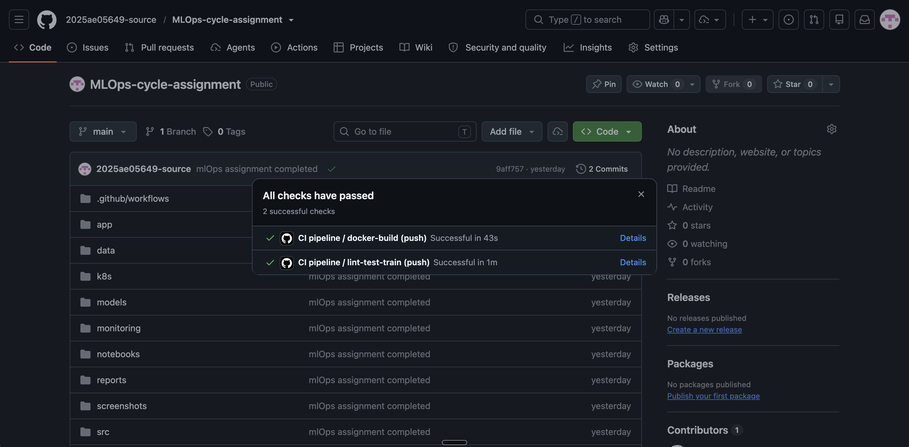
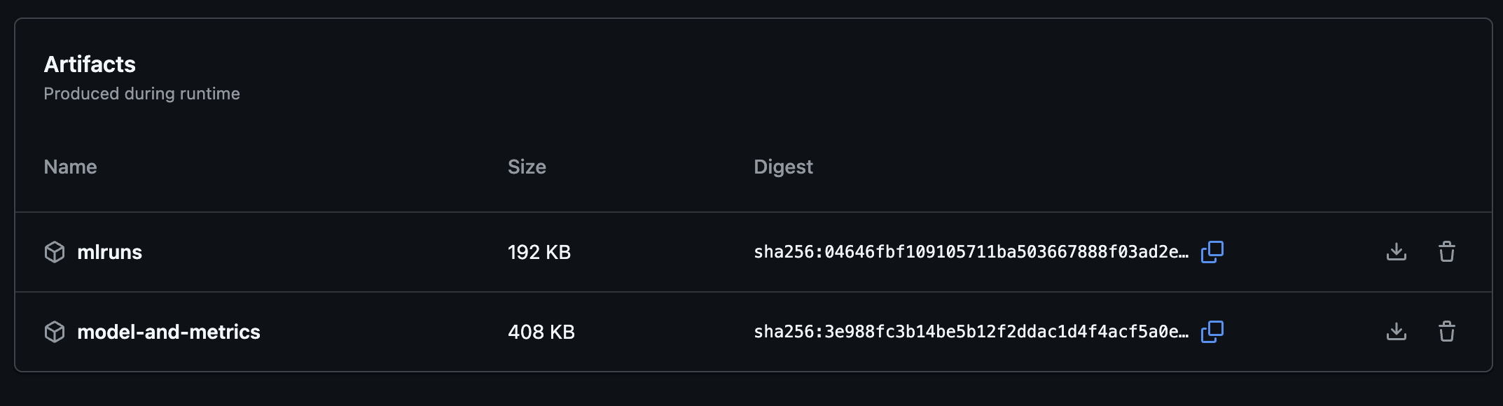
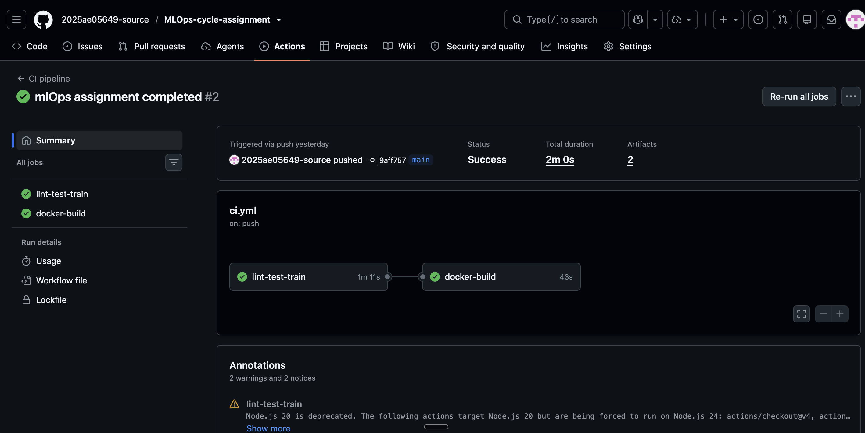
9. Model Containerization (Docker)
The API is written with FastAPI (app/main.py):
Endpoint | Method | Description
/ | GET | welcome message
/health | GET | health check, loads model (used by Kubernetes probes)
/predict | POST | JSON with 13 features -> prediction, label, confidence
/metrics | GET | Prometheus metrics
/docs | GET | Swagger UI (automatic in FastAPI)
Input is validated with a Pydantic model (types and ranges, e.g. sex must be 0 or 1). Invalid input returns HTTP 422. Confidence is the predicted probability of the predicted class.
Dockerfile: based on python:3.12-slim, installs requirements-api.txt, copies app/ and models/model.pkl, runs uvicorn on port 8000.
docker build -t heart-disease-api:v1 .
docker run -d --name heart-api -p 8000:8000 heart-disease-api:v1
curl -X POST http://localhost:8000/predict \
-H "Content-Type: application/json" -d @sample_input.json
Sample response:
{"prediction": 0, "label": "no heart disease", "confidence": 0.8254}
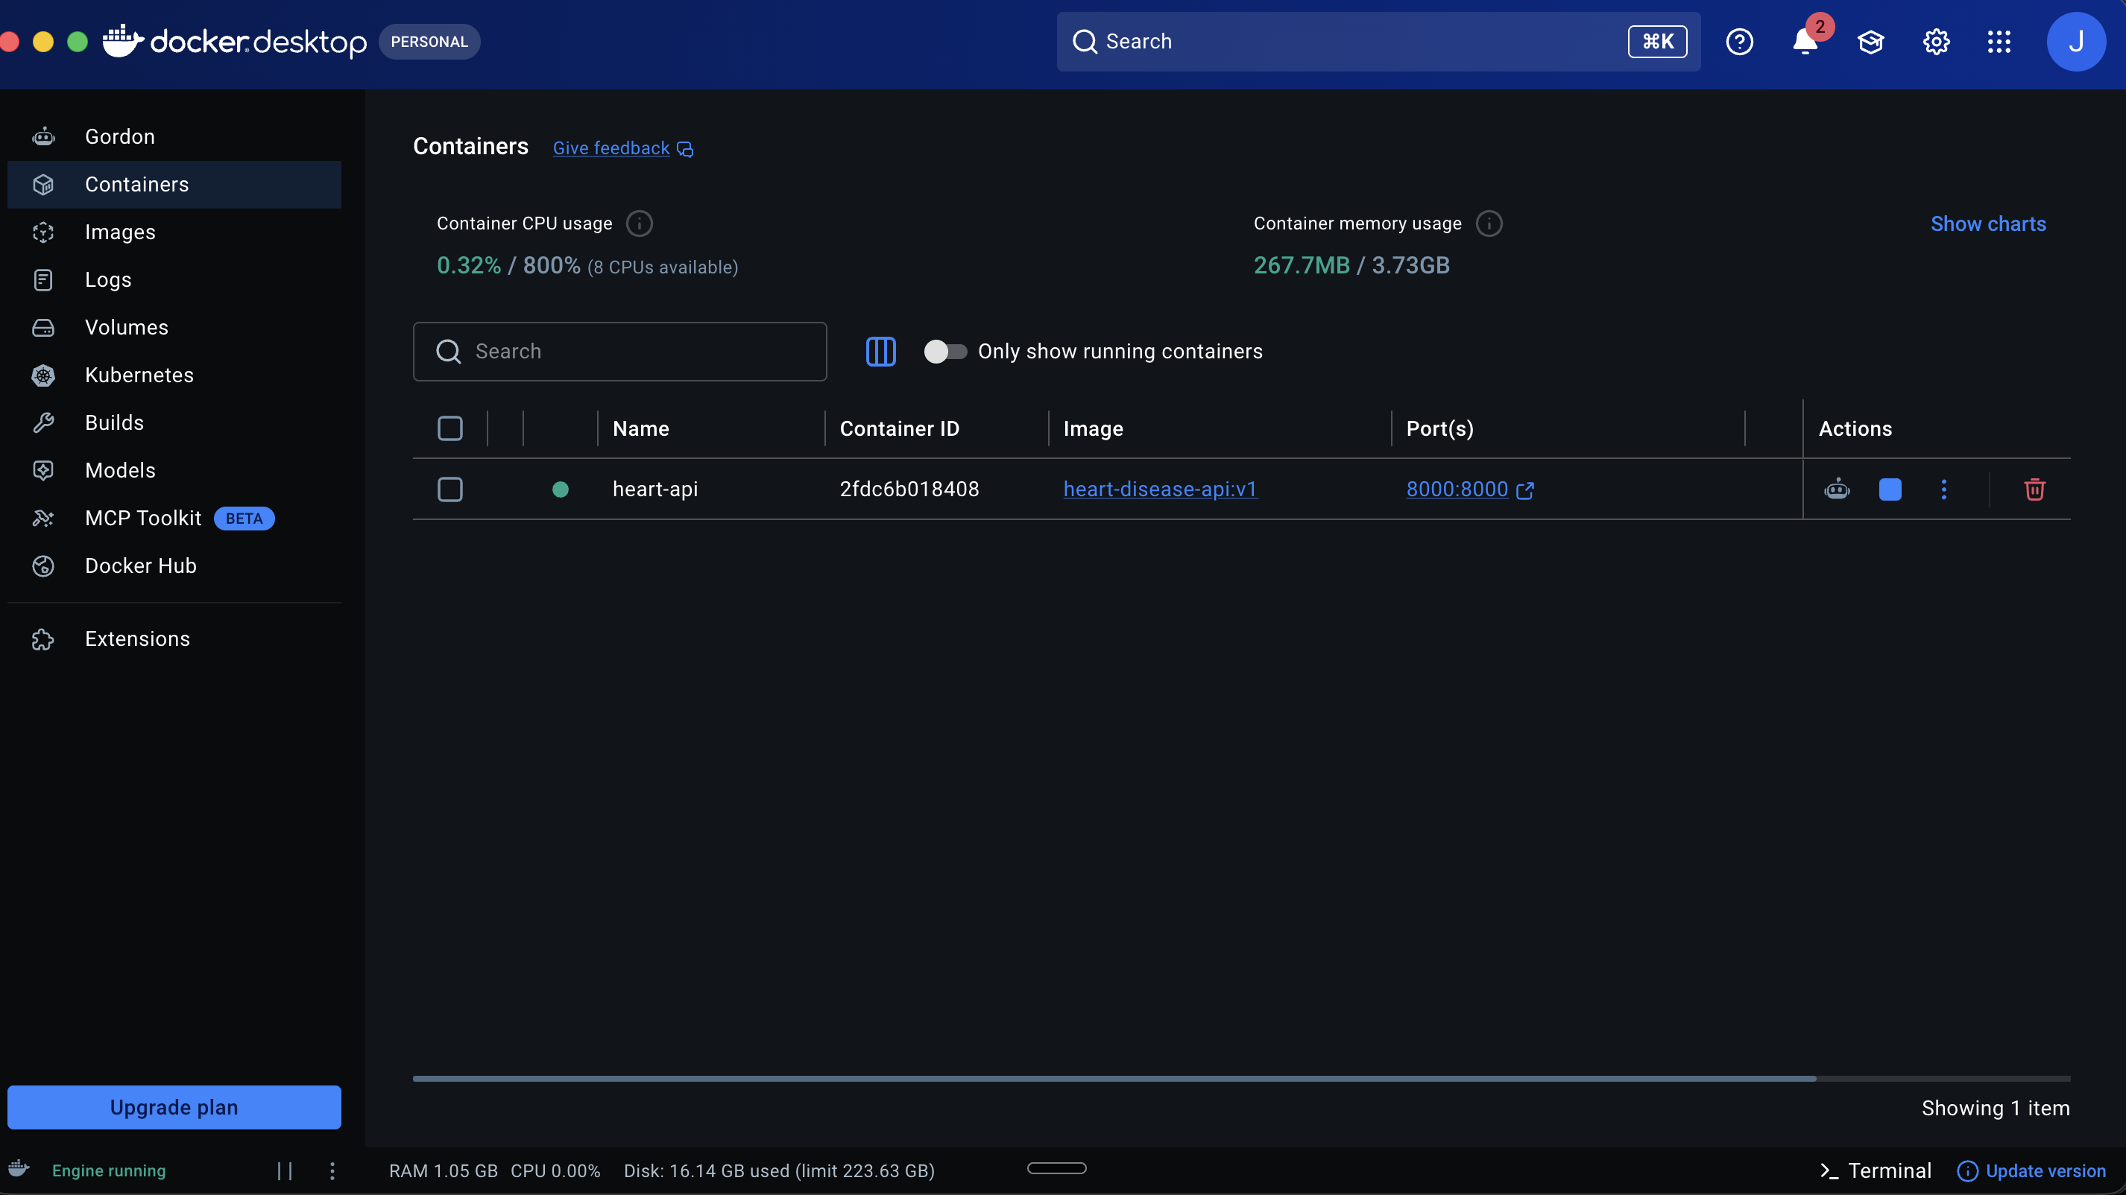

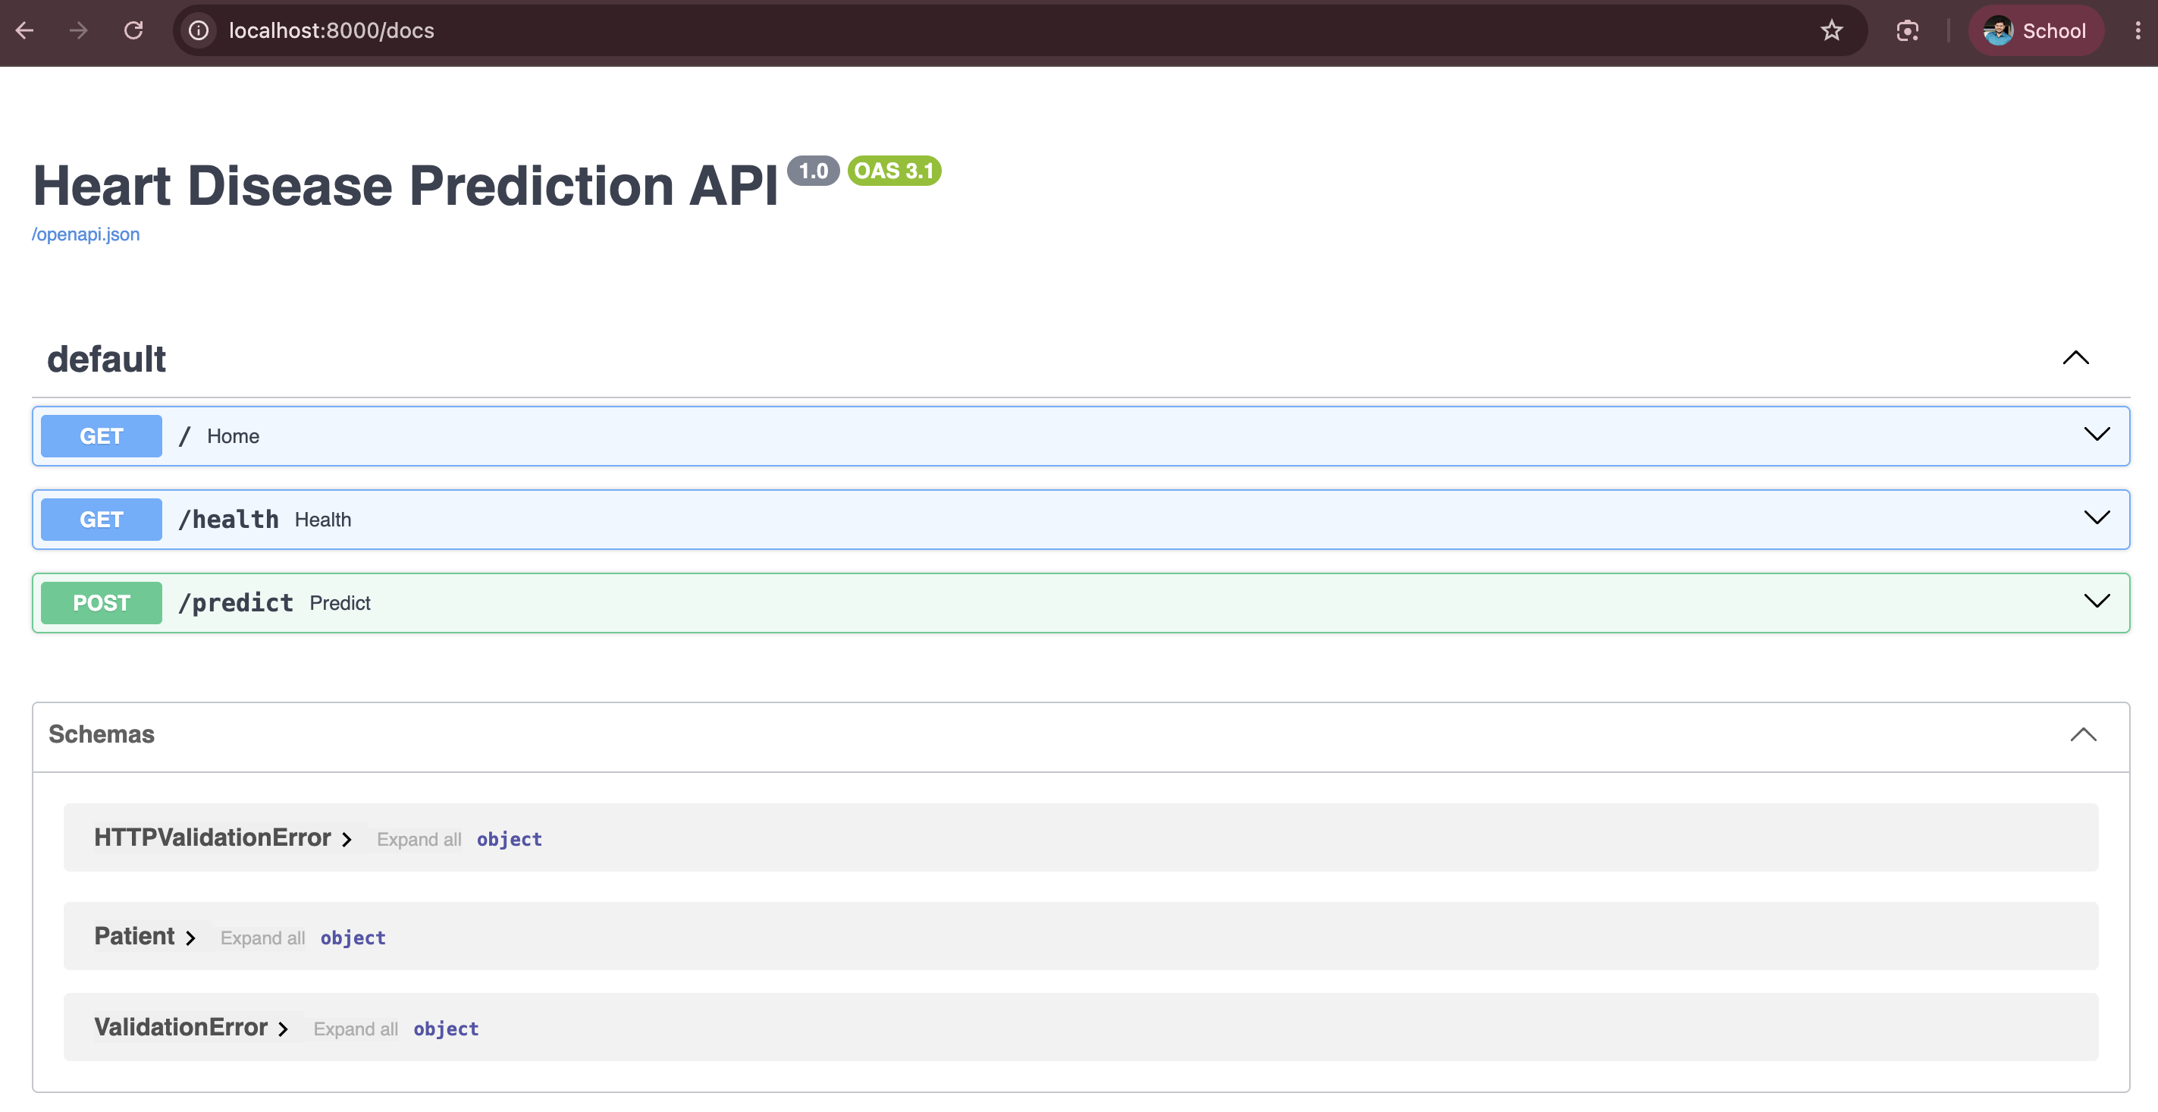

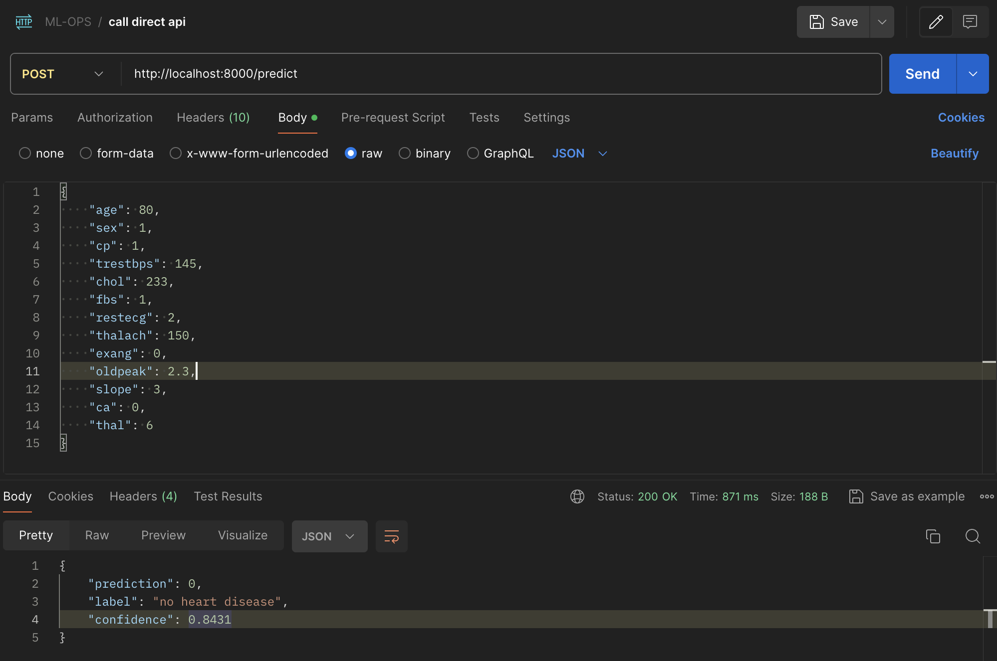

10. Production Deployment (Kubernetes - Minikube)
I deployed to a local Kubernetes cluster using Minikube (Docker driver).
- k8s/deployment.yaml: Deployment heart-api with 2 replicas, CPU/memory requests and limits, readiness and liveness probes on /health. imagePullPolicy: IfNotPresent because the image is loaded directly into minikube (not pushed to a registry).
- k8s/service.yaml: Service of type LoadBalancer, port 80 -> container port 8000.
minikube start --driver=docker
minikube image load heart-disease-api:v1
kubectl apply -f k8s/
kubectl get pods,svc
minikube service heart-api-service --url
curl -X POST <URL>/predict -H "Content-Type: application/json" -d @sample_input.json
On minikube the LoadBalancer stays <pending> until minikube tunnel is running; alternatively minikube service heart-api-service --url gives a local URL. Both pods became Ready and /predict through the service returned the same prediction as the local container.
Access instructions (local testing): run the commands above, then open <URL>/docs in a browser.
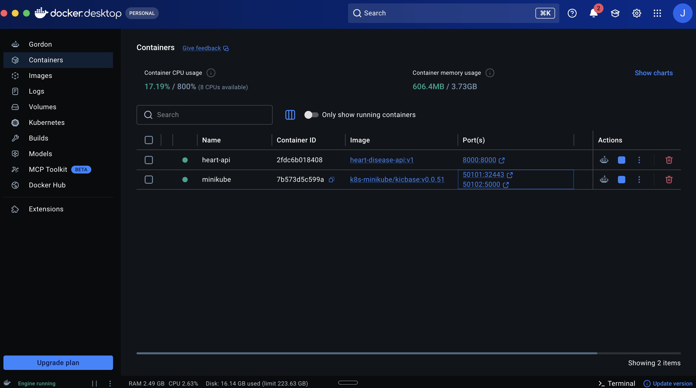

11. Monitoring and Logging
Logging: the API uses Python logging. A FastAPI middleware logs every request (method, path, status code, time taken), and /predict also logs the input and the prediction with confidence. Logs can be seen with docker logs heart-api or kubectl logs -l app=heart-api.
Metrics: using prometheus-client the API exposes on /metrics:
- api_requests_total (labels: method, endpoint, status)
- api_request_latency_seconds (histogram per endpoint)
- predictions_total (label: prediction class)
Prometheus + Grafana: docker-compose.yml starts the API, Prometheus (scrapes /metrics every 5 seconds) and Grafana (port 3300). The Prometheus datasource and a dashboard are provisioned automatically from monitoring/grafana/. The dashboard “Heart Disease API” shows total requests, predictions per class, error count, requests per second per endpoint and average latency. send_requests.sh sends test traffic (including one invalid request so the error panel shows something).

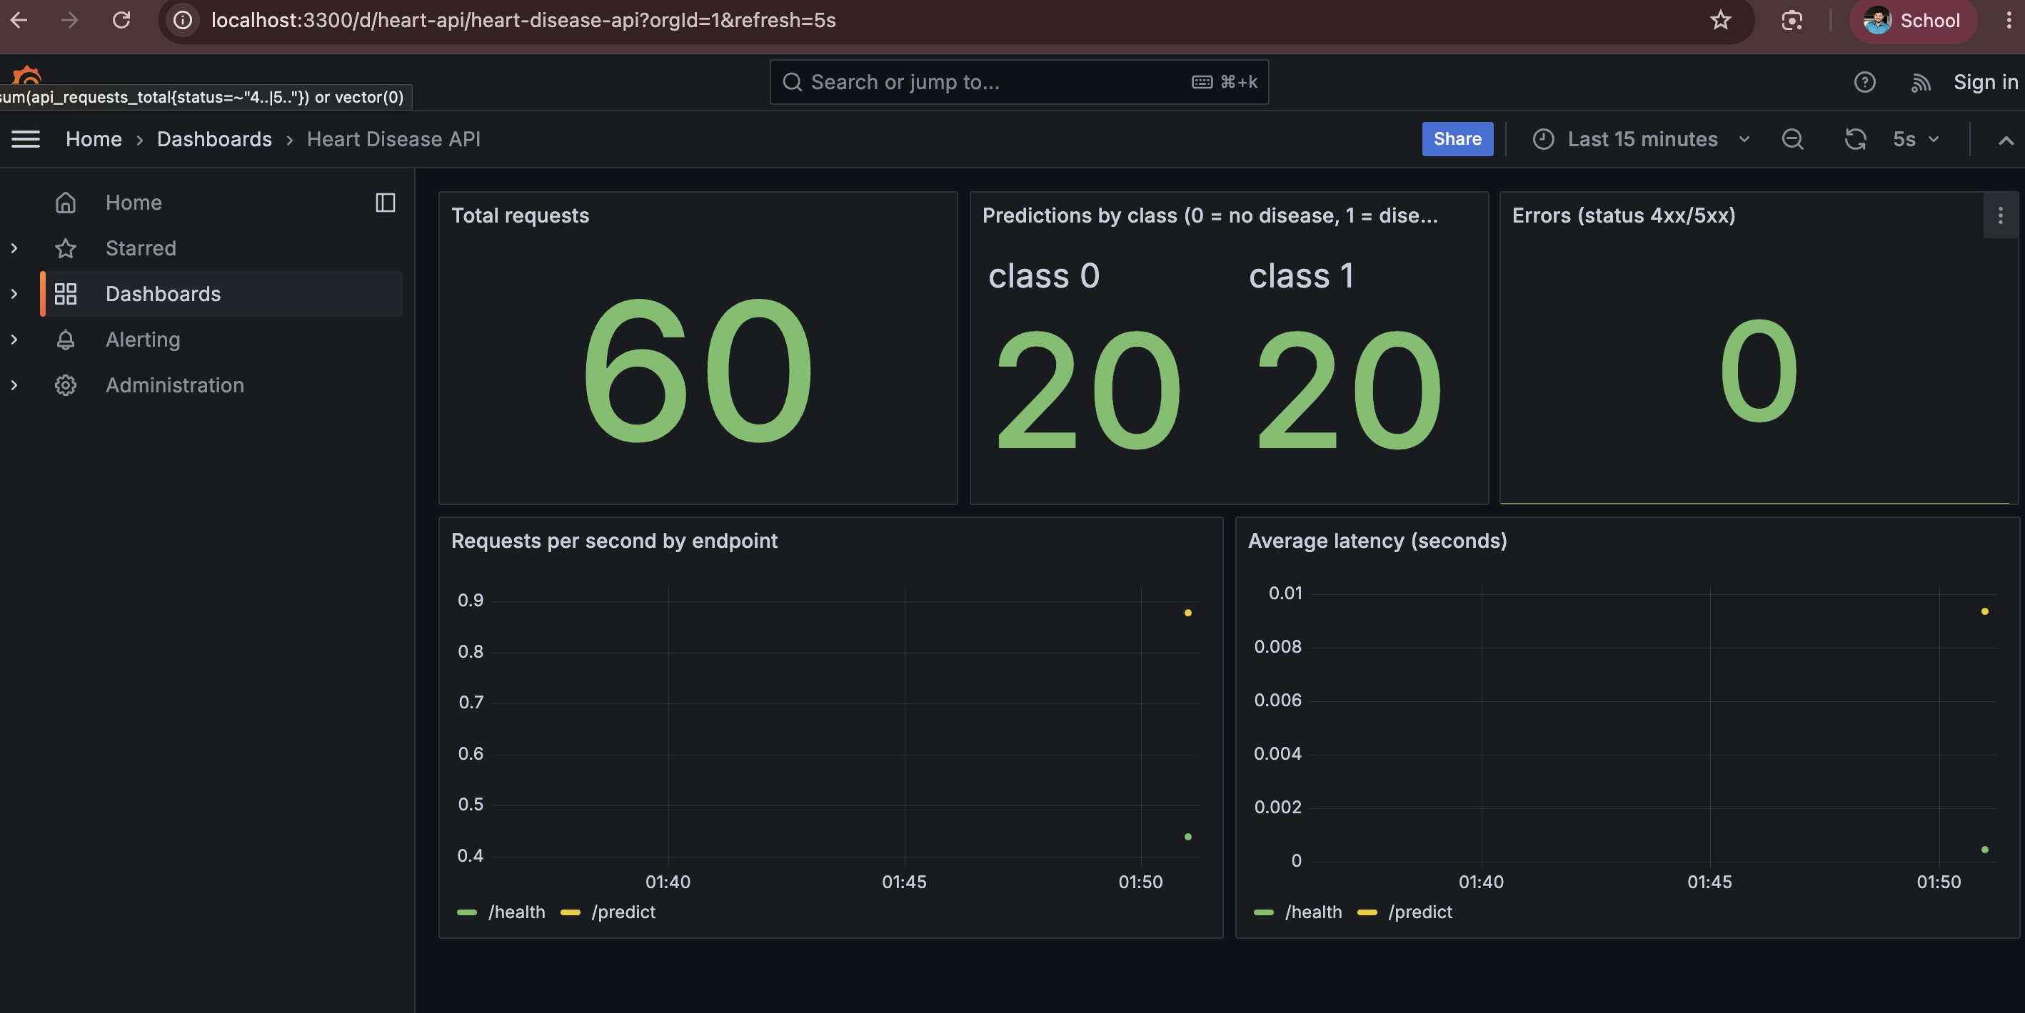12. Architecture
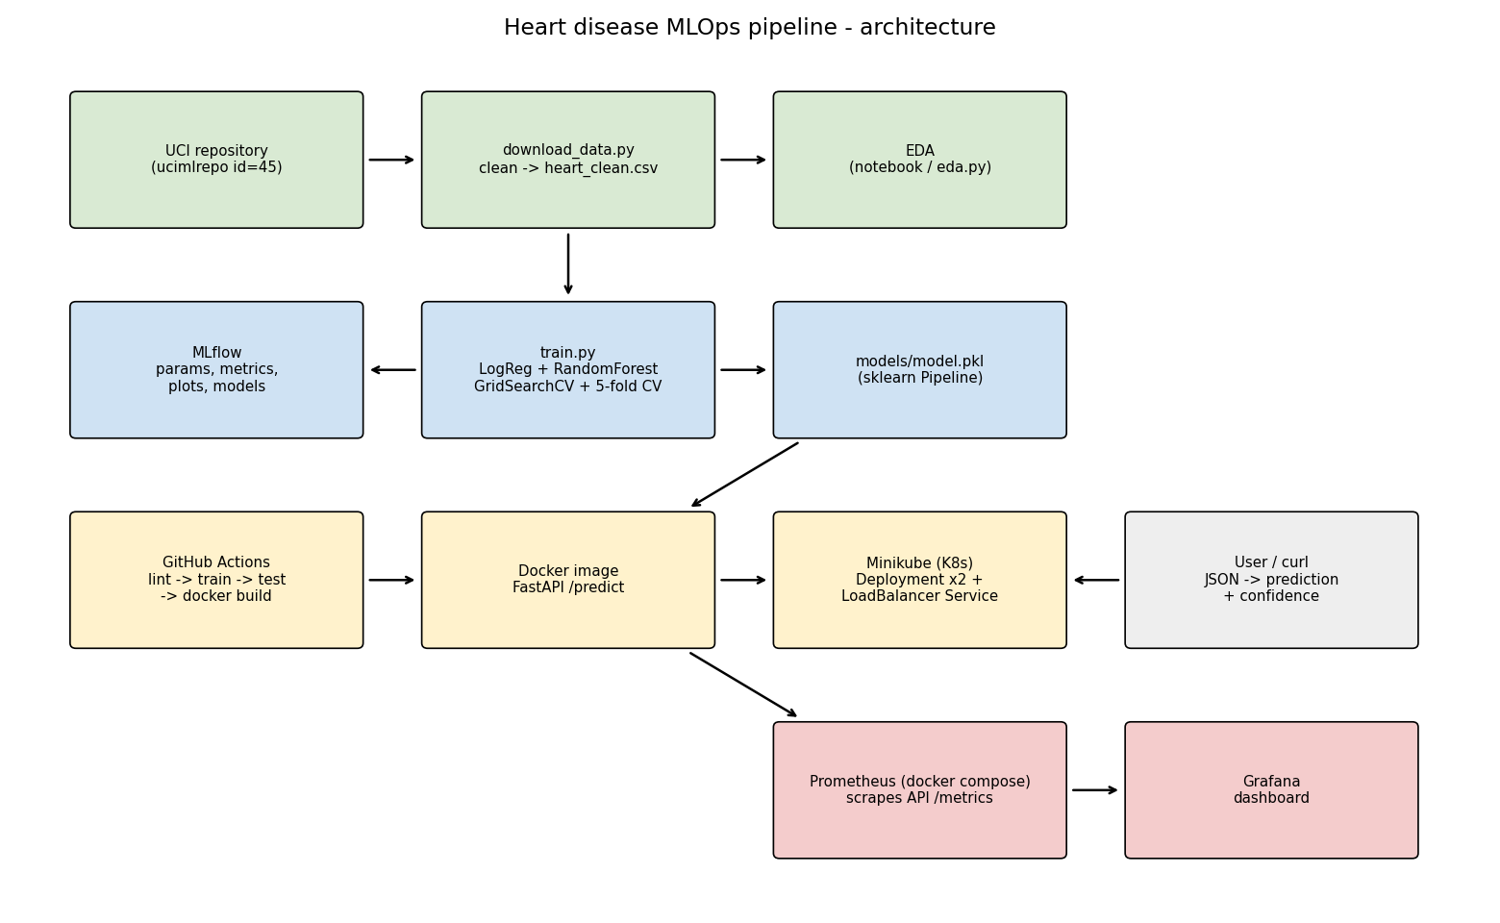
Architecture diagram
Flow: data is downloaded from UCI and cleaned -> EDA -> training with GridSearchCV, logged to MLflow -> best pipeline saved as model.pkl -> packaged into a Docker image with FastAPI -> deployed on Minikube with 2 replicas behind a LoadBalancer service. GitHub Actions automates lint, training, tests and the Docker build on every push. Prometheus scrapes API metrics and Grafana shows them.

13. Challenges and Learnings
- SSL error when downloading data on macOS - fixed by using the certifi certificate bundle.
- Port conflicts on Mac - port 5000 is used by AirPlay so MLflow UI runs on 5001; Grafana is mapped to 3300.
- Image not found in minikube - minikube has its own Docker, so the image has to be loaded with minikube image load and imagePullPolicy set to IfNotPresent.
- LoadBalancer pending on minikube - needs minikube tunnel or minikube service --url.
- Putting preprocessing inside the sklearn Pipeline made the API much simpler and avoided mistakes between training and serving.
Possible improvements: push the image to a registry (Docker Hub / GHCR) from CI, deploy Prometheus/Grafana inside the cluster too, use the MLflow model registry, add data drift monitoring.

14. Links
Code repository: https://github.com/2025ae05649-source/MLOps-cycle-assignment
Demo link : mlOps-assignment recording

- Dataset: https://archive.ics.uci.edu/dataset/45/heart+disease

